# Blood Lactate Prediction Model Documentation

**Redback Operations**

**O2 Algorithm team – Karl Birti**

Blood lactate serves as an indirect marker for biochemical events such as fatigue within exercising muscles. It is a by-product of the muscle cells using glucose, so when the muscles demand more glucose to function lactate production increases. This mechanism of lactate in the blood and muscles as it accumulates begins to limit the amount of oxygen availability. Blood lactate begins to increase until the lactate threshold is reached, then the accumulation of lactate increases rapidly in an exponential fashion. Lactate threshold is a better predictor of performance than VO2max and is a better indicator of exercise intensity than heart rate, this is why LT (lactate threshold) is useful in prescribing exercise intensities (Goodwin et al., 2007).

Figure 1. VO2 in litres per minute plotted against Blood lactate

Studies show that to improve endurance and efficiency you must train beyond the lactate threshold which is calculated as 80% - 90% of HRmax. This figure can be reduced to 50% - 60% in untrained individuals. Creating a model to predict blood lactate could enable cycling users to identify the current state they are training in and give information as to if they are training in the anaerobic window for their lactate threshold. The advantage of training at or above your lactate threshold is to increase your performance and raise your lactate threshold. In terms of cycling, this translates to being able to maintain a higher speed with previously the same effort.

Training at or little above the anaerobic threshold intensity improves both the aerobic capacity and anaerobic threshold level. Anaerobic Threshold can also be determined from the speed-heart rate relationship in the field situation, without undergoing sophisticated laboratory techniques (Ghosh, 2004).

Blood-based methods to determine lactate threshold show less bias and smaller variance than ventilation-based methods when predicting time-trial performance in cool environments. Of the blood-based methods, the inflection point between steady-state lactate and rising lactate (INFL) is shown to be the best method to predict time-trial performance. Lastly, in the hot condition, ventilation-based predictions are less accurate after heat acclimation, while blood-based predictions remain valid in both environments after heat acclimation (Lorenzo et al., 2011).

A recent study demonstrated that to estimate blood lactate for low/moderate intensity that, besides heart rate, respiratory variables are required (Huang et al., 2019). As we have previously constructed a well performing model to predict oxygen uptake (VO2), forming a model to predict blood lactate would extend the impact and importance of understanding oxygen uptake and the role of simple metrics for predicting blood lactate.

Not only will the blood lactate prediction model be a useful training tool for cyclists, but in terms of the incentive part of the project this model can be used as a guide for exercise intensity curated to the individual. One way this could work is by rewarding riders with coins for pushing their physiological boundaries and exercising at a level that is at or beyond the lactate threshold. This would encourage users to train hard and reap the benefits of improving their endurance and efficiency. The incentive would be worked into levels of exertion that the rider performs with higher more difficult levels giving greater rewards, this in part could be modulated by the predicted blood lactate levels that they are operating at in their bout of riding.

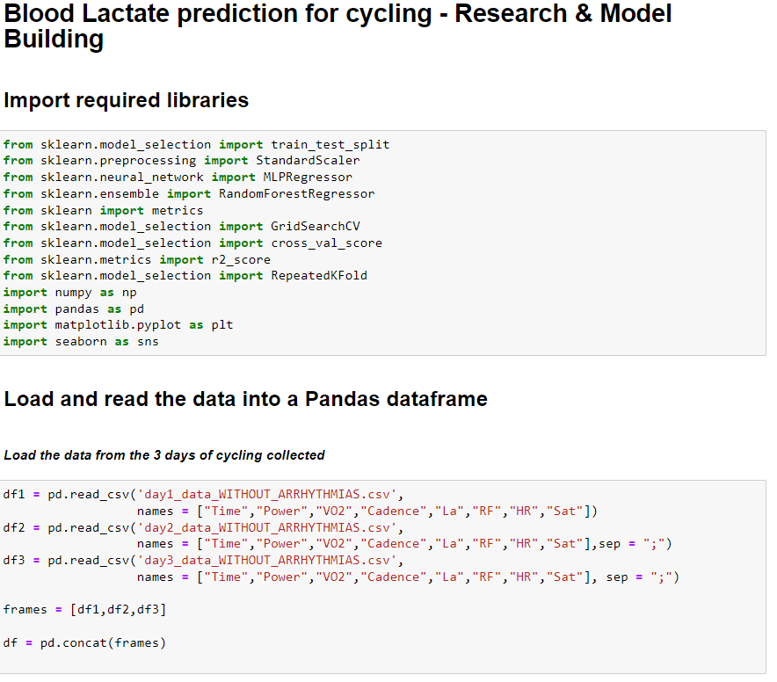 With the 3 datasets (df1, df2, df3) they are combined into a single dataframe to commence exploratory data analysis.

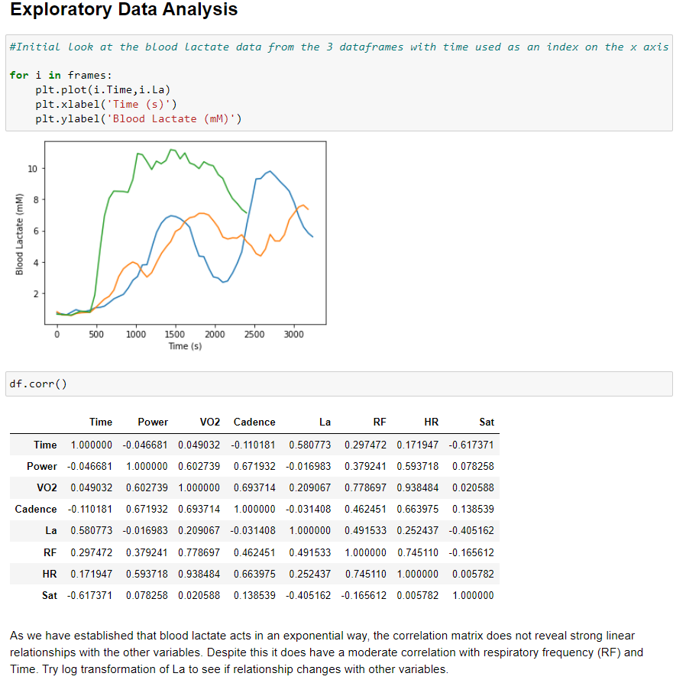

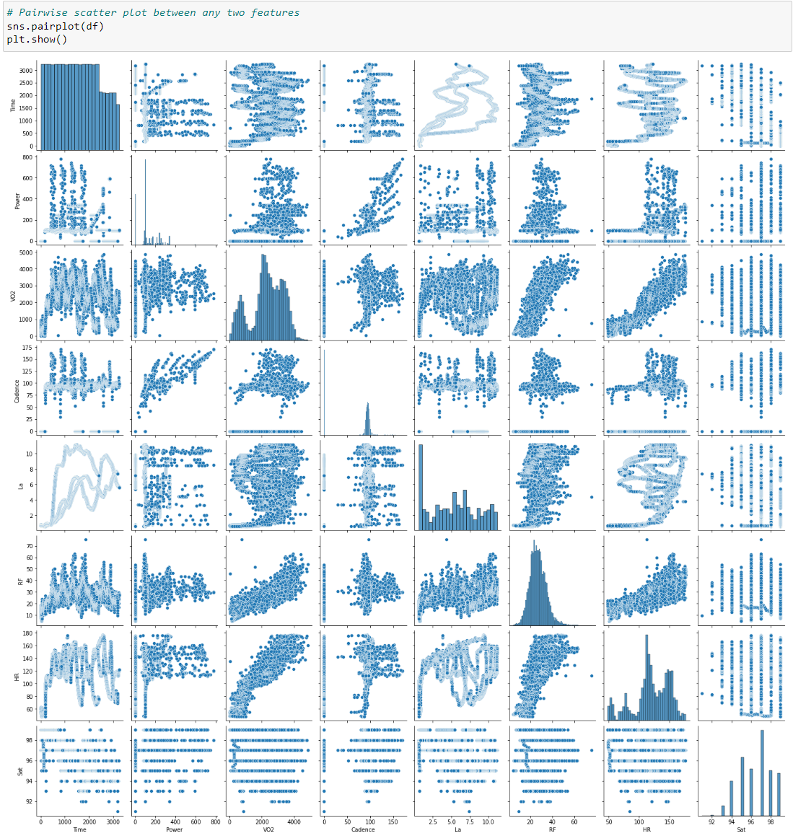

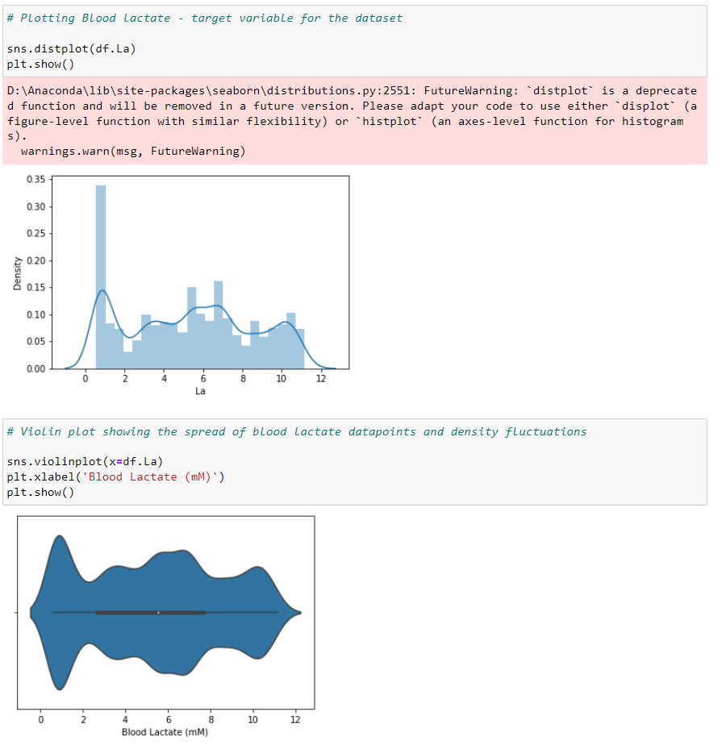

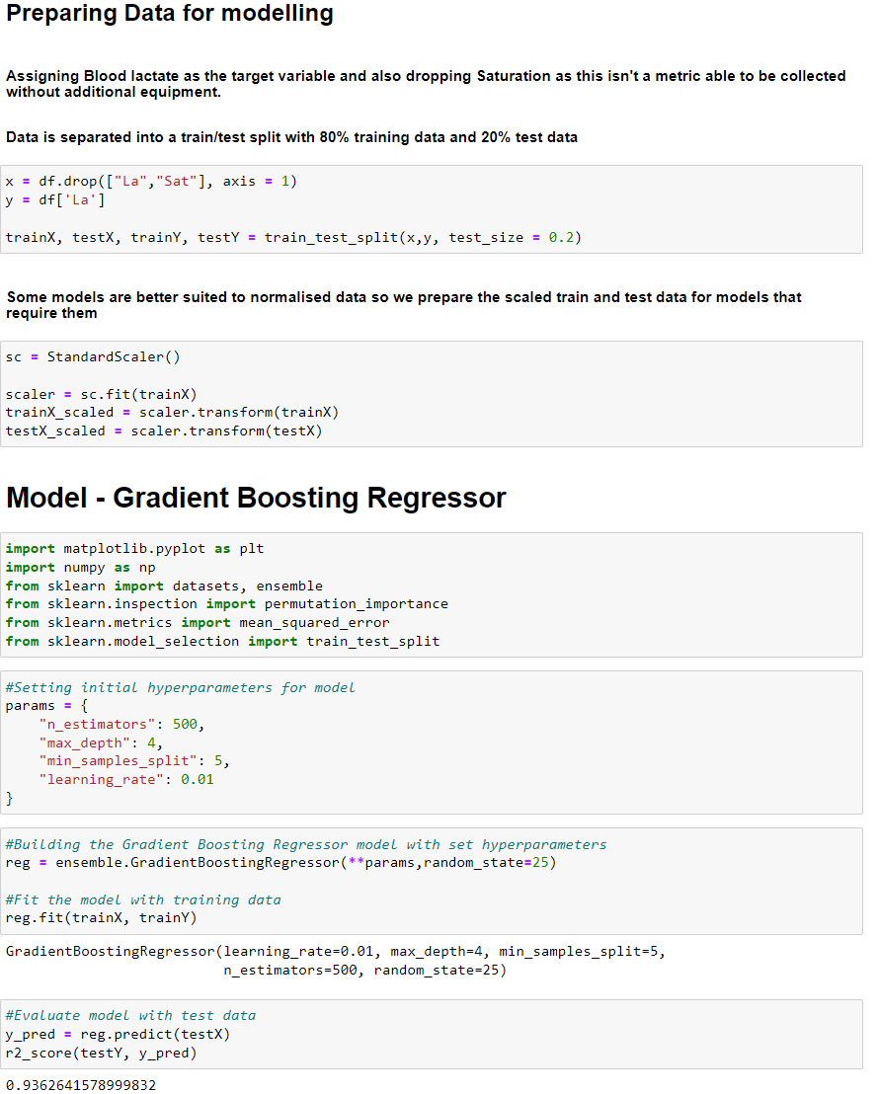

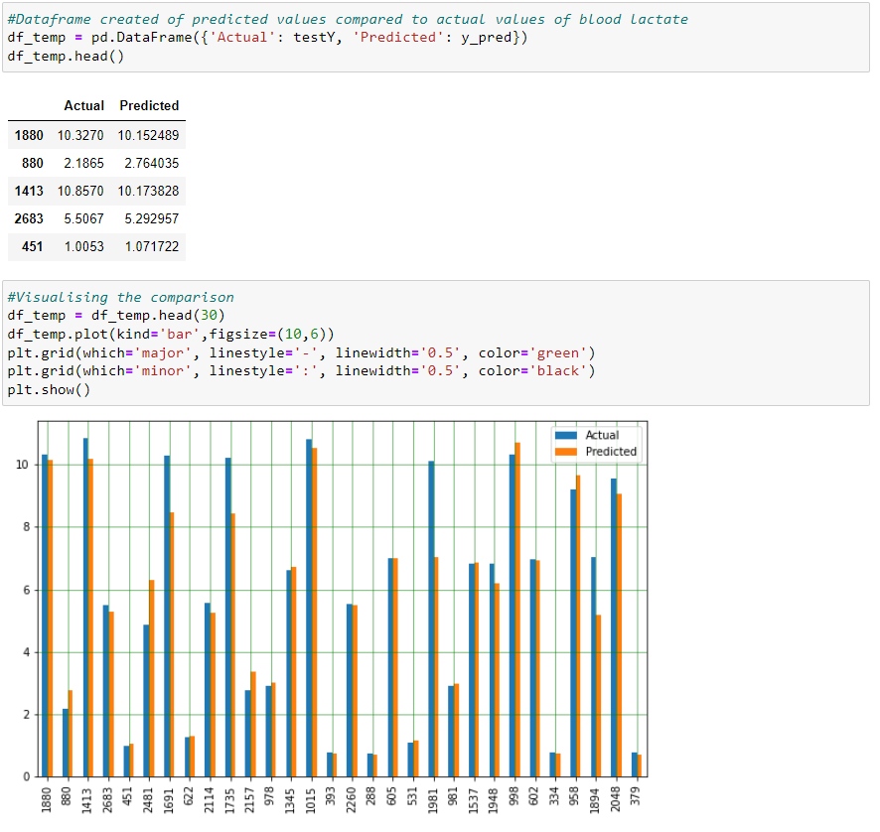

As we can see in the figures above, VO2 interestingly is not being shown as an important feature for predicting blood lactate, with a value of near zero on both methods of checking. As VO2 is usually a difficult metric to collect this is positive news for constructing the prediction model as all other features are metrics that can be easily collected with inexpensive equipment.

# Model Optimization

Using the GridSearchCV function that comes in Scikit-learn's model_selection package we can loop through predefined hyperparameters and fit estimator (model) on the training set.

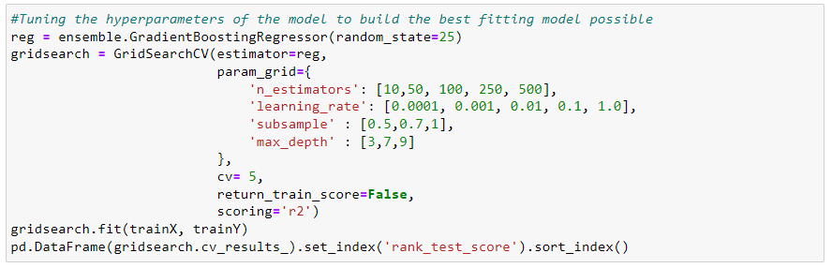

If we look at the mean accuracy for the cross validation, the best ranked model performs at 99.02% accuracy which is a strong model.

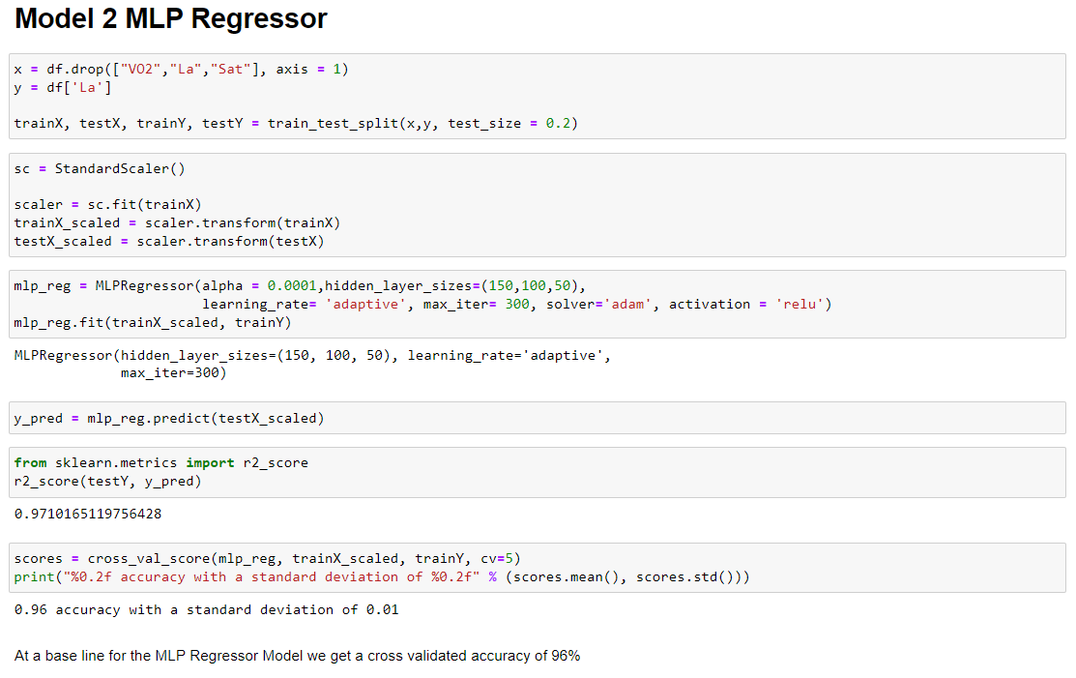

## Model Results Summary Table

|  |  |  |
| --- | --- | --- |
| Model Type | Optimal Parameters (Grid Search) | R2 Score |
| Gradient Boosting Regressor | {'learning_rate': 0.1, 'max_depth': 9, 'n_estimators': 500, 'subsample': 0.7} | 0.9946433172895832 |
| MLP Regressor | MLPRegressor(activation='tanh', hidden_layer_sizes=(150, 100, 50), learning_rate='adaptive', max_iter=500) | 0.987896403935139 |
| Random Forest Regressor | {'max_depth': 400, 'n_estimators': 100} | 0.9834825630374389 |

Gradient Boosting Regressor was the most effective machine learning algorithm once optimized to build a prediction model for blood lactate with an accuracy of 99.46%. The MLP Regressor and Random Forest Regressor respectively had accuracies of 98.79% and 98.34%. Overall, the 3 optimized models built here were highly accurate in predicting blood lactate in the test data.

# Conclusion and Recommendation

In this research-based project we looked at the impact that several metrics (time, power, cadence, respiratory frequency, heart rate) have on the production of blood lactate (La). The ways in which blood lactate is measured are not practical or affordable for many people. The purpose of this study was to investigate machine learning algorithms with metrics commonly collected during cycling and cycling simulators to predict blood lactate levels for cyclists. Three models were chosen for this task and all of them achieved strong accuracy when tasked with predicting the test data. Given the results, it would be possible to apply this on new real data collected and refine the model further with greater samples collected.

As blood lactate is an indicator of fatigue/exhaustion, this model may act as a window to see how hard the riders are pushing themselves. The blood lactate prediction model could therefore be integrated into the incentive allocation of the game to reward players for upper levels that they push their blood lactate.

# References

GHOSH, A. K. 2004. Anaerobic threshold: its concept and role in endurance sport. *The Malaysian journal of medical sciences : MJMS,* 11**,** 24-36.

GOODWIN, M. L., HARRIS, J. E., HERNÁNDEZ, A. & GLADDEN, L. B. 2007. Blood lactate measurements and analysis during exercise: a guide for clinicians. *Journal of diabetes science and technology,* 1**,** 558-569.

HUANG, S. C., LIU, K. C., CHEN, Y. J., CASABURI, R., LIAO, M. F., FU, T. C. & SU, H. R. 2019. Noninvasive prediction of Blood Lactate through a machine learning-based approach. *Scientific Reports,* 9.

LORENZO, S., MINSON, C. T., BABB, T. G. & HALLIWILL, J. R. 2011. Lactate threshold predicting time-trial performance: impact of heat and acclimation. *J Appl Physiol (1985),* 111**,** 221-7.